Bolingbrook Driving Range and Rabito Golf Academy
2018 Junior Golf Development Program

Junior Camp Schedule
These multi-Day camps are 6 hours of instruction, gift, competitions and prizes. Classes are separated by the following age groups (5-7), (8-11), (12-15)
Fees: $149 non-resident, $139 resident.

Monday to Wednesday Camps: Ages (5-7yrs) and (8-11yrs)

Session 1 (5-7yrs) June 4-6 9:00am to 11:00am
Session 2 (8-11yrs) June 4-6 12:00pm to 2:00pm
Session 3 (8-11yrs) June 11-13 9:00am to 11:00am
Session 4 (5-7yrs) June 11-13 12:00pm to 2:00pm
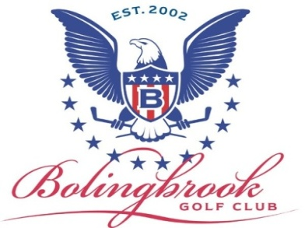
Session 5 (5-7yrs) June 18-20 9:00am to 11:00am
Session 6 (8-11yrs) June 18-20 12:00pm to 2:00pm
Session 7 (8-11yrs) June 25-27 9:00am to 11:00am
Session 8 (5-7yrs) June 25-27 12:00pm to 2:00pm
Session 9 (5-7yrs) July 9-11 9:00am to 11:00am
Session 10 (8-11yrs) July 9-11 12:00pm to 2:00pm
Session 11 (8-11yrs) July 16-18 9:00am to 11:00am
Session 12 (5-7yrs) July 16-18 12:00pm to 2:00pm
Session 13 (5-7yrs) July 23-25 9:00am to 11:00am
Session 14 (8-11yrs) July 23-25 12:00pm to 2:00pm
Session 15 (8-11yrs) July 30- Aug 1 9:00am to 11:00am
Session 16 (5-7yrs) July 30- Aug 1 12:00pm to 2:00pm
Session 17 (5-7yrs) Aug 6-8 9:00am to 11:00am
Session 18 (8-11yrs) Aug 6-8 12:00pm to 2:00pm

Bolingbrook Driving Range and Rabito Golf Academy
2018 Junior Golf Development Program
Junior Camp Schedule
These multi-Day camps are 6 hours of instruction, gift, competitions and prizes. Classes are separated by the following age groups (5-7), (8-11), (12-15)
Fees: $149 non-resident, $139 resident.

Thursday to Friday camps: Ages 12-15yrs

Session 19 June 7-8 9:00am to 12:00pm
Session 20 June 14-15 9:00am to 12:00pm
Session 21 June 21-22 9:00am to 12:00pm
Session 22 June 28-29 9:00am to 12:00pm
Session 23 July 5-6 9:00am to 12:00pm
Session 24 July 12-13 9:00am to 12:00pm
Session 25 July 19-20 9:00am to 12:00pm
Session 26 July 26-27 9:00am to 12:00pm
Session 27 Aug 2-3 9:00am to 12:00pm

